Rocks and Minerals Learning Targets
Page # | Target | With Help | On My Own | Teach It
 | I know that hardness, color, luster, and streak are physical properties of minerals.
 | I can use the Mohs Hardness Scale to predict the hardness of a mineral.
 | I can use the physical properties hardness, color, luster, and streak to identify specific minerals.
 | I can test the physical properties of minerals.
 | I can describe how a metamorphic rock is formed.
 | I can describe how an igneous rock is formed.
 | I can describe how a sedimentary rock is formed.
 | Using the rock cycle I can correctly predict what processes will produce each type of rock.

Vocabulary Terms: Make flashcards with definitions and pictures of each to help you study.
Cleavage (notes) | Color pg. 94 | Deposition pg. 308 | Crystal pg. 304
Fracture (notes) | Grain pg. 304 | Hardness pg. 95 | Igneous rock pg. 306
Intrusive rock pg. 316 | Extrusive rock pg. 315 | Luster pg. 94 | Metamorphic rock p307
Mineral pg. 304 | Mohs scale pg. 95 | Rock pg. 304 | Rock cycle pg. 307
Sediment pg. 306 | Sedimentary rock p306 | Streak pg. 96 | Texture pg. 304

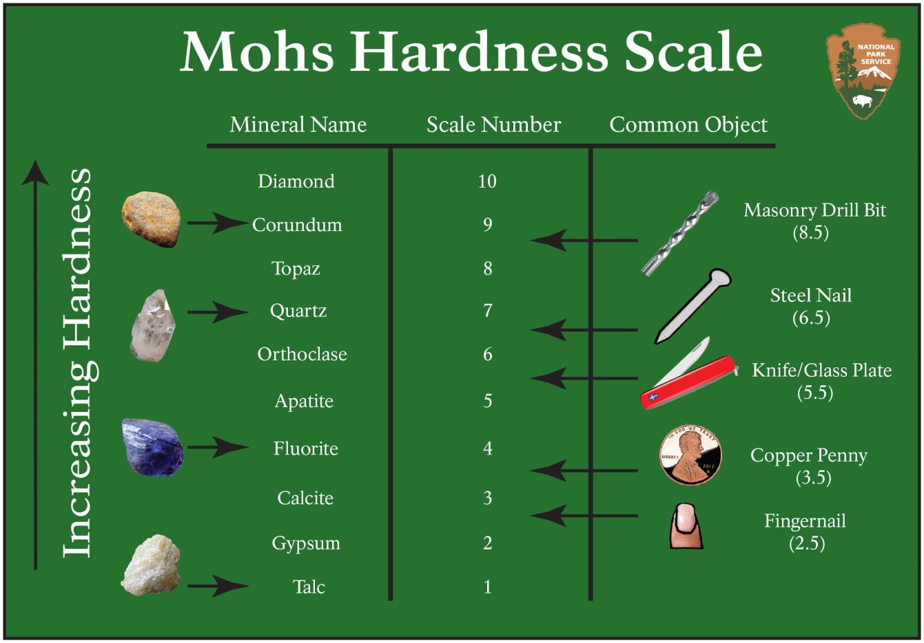

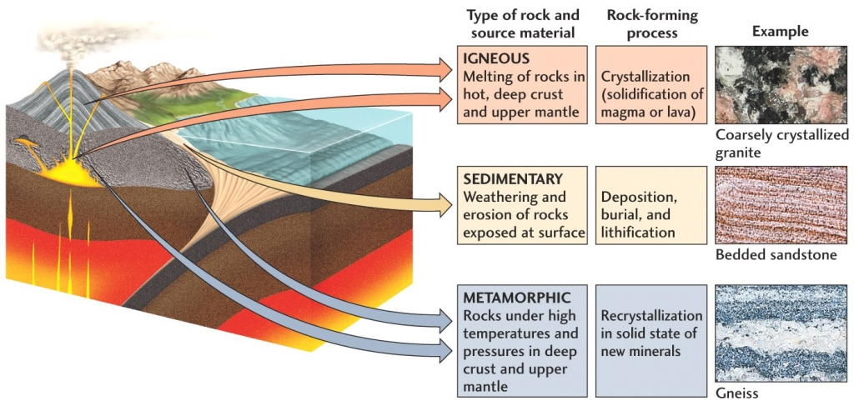

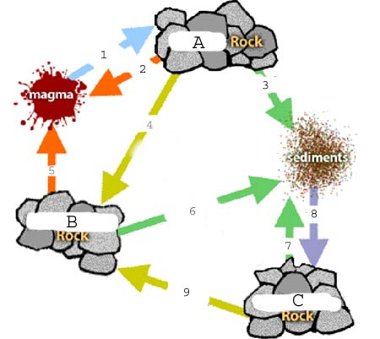
Completely fill in the diagram below using correct science terminology to explain the processes happening in the Rock Cycle.

