**Marble Machine Journal**

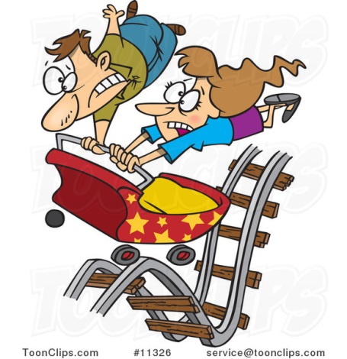

As scientists work to solve problems, they very often document their work as their experiment progresses. This allows them to remember questions that arise, how problems are solved and strategies they may have tried that were unsuccessful!

As you plan, work on and complete your Marble Machines, you will model this behavior.

You need to document your work for each day below. In the end, **you will create your own** electronic version of this journal to turn in to your teacher. It may be easier to create this electronic version each evening for homework.

**Planning Day**

1. Each person should take a picture of the approved blue print for their own digital journal.

2. Write a list of things you need to do tomorrow to get started:

__________________________________________________________________________________________

**After Day 1**

1. Each person should take a picture of the approved blue print for their own digital journal.

2. Complete the following:

Worked on:_______________________________________________________________________________

Problem(s) Encountered: ___________________________________________________________________  
  
Solutions tried to fix problem ________________________________________________________________

Was it successful? Yes/No

**After Day** 2

1. Each person should take a picture of the approved blue print for their own digital journal.

2. Complete the following:

Worked on:_______________________________________________________________________________

Problem(s) Encountered: ___________________________________________________________________  
  
Solutions tried to fix problem ________________________________________________________________

Was it successful? Yes/No

**After Day 3**

1. Each person should take a picture of the approved blue print for their own digital journal.

2. Complete the following:

Worked on:_______________________________________________________________________________

Problem(s) Encountered: ___________________________________________________________________  
  
Solutions tried to fix problem ________________________________________________________________

Was it successful? Yes/No

**After Day 4**

1. Each person should take a picture of the approved blue print for their own digital journal.

2. Complete the following:

Worked on:_______________________________________________________________________________

Problem(s) Encountered: ___________________________________________________________________  
  
Solutions tried to fix problem ________________________________________________________________

Was it successful? Yes/No

**After Day 5**

1. Each person should take a picture of the approved blue print for their own digital journal.

2. Complete the following:

Worked on:_______________________________________________________________________________

Problem(s) Encountered: ___________________________________________________________________  
  
Solutions tried to fix problem ________________________________________________________________

Was it successful? Yes/No  
  
**Day 6 – Final Product Information**: Include all information below.

1. Take a picture of your final product and include the questions below in your digital journal.

2. Distance of your track(use cm):_____________________________________

3. Time for your marble to go through entire machine (use s):_________________________

4. Speed of the marble (take the average of 3 trials):_______________________________________

5. How much did you change your original design?

I didn’t A little changed Several changes made A lot/many Most of my design changed

6. Did you and your partner work well together? Yes / No **EXPLAIN!!**   
OR

Did you enjoy working by yourself? Yes / No **EXPLAIN!**

**Electronic Version**

Pick any app that will allow you to create your own journal entry with picture and explanation for each day. Possible apps are Pages, Keynote, and Strip Design. You may be familiar with other apps. Use what you want, but ensure that you are able to turn in your document as a PDF when you are finished.

**You will end up with at least 8 pages in your document. Each day goes on a different sheet of paper.**

1. Title Page including project title, your first and last name and your partner’s name.

2. Title each day as I have titled each section above. (Title Page, Planning Day, After Day 1, etc…)

3. Insert the picture for that day. **YOU MUST HAVE A PICTURE FOR EACH ENTRY!**

4. Use the information you wrote down to write **complete paragraphs** explaining your work for that day. The

following must be correct: grammar, spelling, and sentence structure. Make sure your thoughts are complete

and clear.

5. Your teacher will direct you in turning in this document. You will **print** your journal to turn in to me.