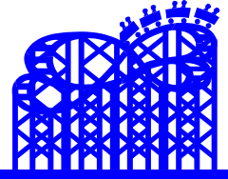
Major Fun, Major Grade!

Objective: Using your knowledge of motion, forces, and energy, design and construct a “roller coaster” for a marble that meets all the requirements listed below using the same materials.

Materials:
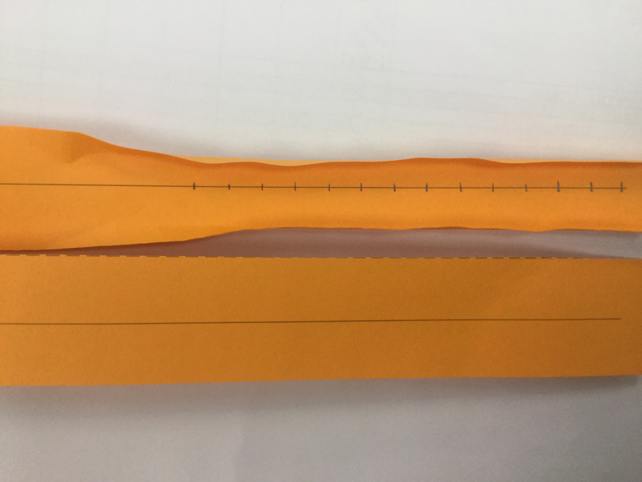
Each group will receive the same amount of the following supplies and the same amount of time to work. You will not bring anything from home.
- 1 sheet of poster board
- 3 sentence strips (cut in half long ways, fold up sides to secure to poster)
- tape
- 1 marble for practice to be returned to the teacher daily

This is very important: You should put your name on all supplies as they are given to you. You are responsible for keeping track of materials. They will NOT be replaced, and you may not bring any from home.
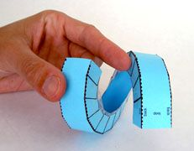
Roller Coaster Requirements: (See details on back.)
- 1 vertical 360° loop
- a 5-cm jump
- a “stall” (with no stopper)
- a trap door / hole
- a 5-cm hill
- a trap or stopper at the end to stop the marble
- Speed will be calculated (cm/s) and written on the front of the poster board. Formula, equation, answer and correct units should all be present. SHOW ALL TIMES AND DISTANCE for each track section.

Planning Requirements:
- Tonight you will do an individual design, complete with stunt labels. This is due tomorrow.
- At our next class you will combine your design with your partner’s design for your official blueprint and draw it on a new graph paper. The graph paper is scaled to the poster board.
- After you’ve drawn your blueprint, consult with your teacher to obtain a “Building Permit.”
- Points will be deducted if the following information is incomplete or missing on your blueprint:

      - First and last names of ALL in your group on front of blueprint
      - all six obstacles labeled and spelled correctly
      - extra tricks also labeled and spelled correctly
      - potential and kinetic energy labeled where
both are at their maximum

Working Requirements
- After beginning to build, you may discover that you have to make changes to your marble machine to get it to work. You do not need to ask for permission to make changes. Since your blueprint must match your machine, you must show these corrections on the graph paper by using a colored marker, colored pen, or colored pencil. Keep original design. Do not erase any of your original design. I will evaluate your changes when I grade your project to ensure that your blueprint is to scale.

- When you think you are finished, grade your marble machine with your own gradesheet before asking your teacher to grade it.

- You must work and clean up with your partner for the 5 days at all times. This is 50% of your grade.

Other Information:
- If you are absent 2 or more days, you will be responsible for creating your own roller coaster.
- No student may “play with”, “test out”, “try out”, “borrow from”, or touch any project other than his/her own. If you are found doing this, your team will lose points.
5 centimeters

5 cm

Vertical 360° Loop
Make sure the marble goes all the way around and doesn’t get to the top and just drop down. There is no height requirement.

5-centimeter Jump
5-cm of empty space to another platform/runway. This is not a “drop.”
The receiving strip should not be lower than the launching strip. This will be measured as shown here.

5-centimeter Hill
The marble must go up 5- centimeters and over. This will be measured as shown here.

hole/door

Stall
The marble should go up a ramp, lose enough energy to make it turn around and go the other way. You should not put anything at the end of the ramp to make the marble turn around.

Trap Door
This is made from one strip of paper. The marble should have enough energy to roll over a door or hole you have cut in your runway, hit a wall or stall and change directions to come back and go through the hole and drop to another platform.

Extra credit is available for only the following tricks if they are successful:
  - longer jump (7.5 cm or longer) You will receive points for the required jump and extra credit points too!
  - higher hill (7.5 cm or higher) You will receive points for the required hill and extra credit points too!
  - extra 360 loops
  - extra 5-cm jumps
  - extra 5-cm hills

Grade Sheet for Marble Machines

_____ Day 1 (10 points) Working together and clean up, follow directions for building permit

_____ Day 2 (10 points) Working together and clean up

_____ Day 3 (10 points) Working together and clean up

_____ Day 4 (10 points) Working together and clean up

_____ Day 5 (10 points) Working together and clean up
Materials Used
 | PB | TAPE SS1 | SS2 | SS3
Date

Daily Supplies Used and Returned
M1 | M2 | M3 | M4 | M5 |  | K1 | K2 | K3 | K4 | K5
out |  |  |  |  |  | out
in |  |  |  |  |  | in

Each of the following is worth five points.

_____ Were the names of everyone in the group on the poster and the design sheet? (yes/no)

_____Did the approved drawing (with corrections necessary) and the actual marble machine match?
(yes/no)

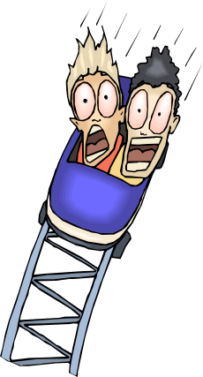
_____Was speed calculated correctly with formula, equation, answer and units written on the board?
(yes/no)

_____Was the marble able to go through the entire machine on the first try? (yes/no)

_____Did the 360 vertical loop work as described in the directions? (yes/no)

_____Did the stall work as described in the directions? (yes/no)

_____Was there a 5cm jump as described in the directions and was it successful? (yes/no)

_____Was there a trap door that allowed the marble to cross over it and then fall through it on the next
pass?(yes/no)

_____Was there a 5cm hill as described in the directions and was it successful? (yes/no)

_____ Was there a trap/stopper at the end? (yes/no)

_____Extra points for______________________________________

Grade Sheet for Marble Machines

_____ Day 1 (10 points) Working together and clean up, follow directions for building permit

_____ Day 2 (10 points) Working together, cleaning up & returning all supplies

_____ Day 3 (10 points) Working together, cleaning up & returning all supplies

_____ Day 4 (10 points) Working together, cleaning up & returning all supplies

_____ Day 5 (10 points) Working together, cleaning up & returning all supplies

Each of the following is worth five points.

_____Did the approved drawing (with corrections if necessary) and the actual marble machine match?
(yes/no)

_____ Were the names of everyone in the group on the front of poster and design sheet? (yes/no)

_____Was the marble able to go through the entire machine on the first try? (yes/no)

_____Did the 360 vertical loop work as described in the directions? (yes/no)

_____Did the stall work as described in the directions? (yes/no)

_____Was there a 5-cm jump as described in the directions and was it successful? (yes/no)

_____Was there a trap door that allowed the marble to cross over it and then fall through it?(yes/no)

_____Was there a 5-cm hill as described in the directions and was it successful? (yes/no)

_____Was there a trap/stopper at the end? (yes/no)

_____Was speed calculated correctly with formula, equation, answer and units on front of poster? (yes/no)

_____Extra points for__________________________________________________

