Name ____________________ Period___

**Force and Motion Learning Targets Review**

**LT1- I can compare and contrast how kinetic and potential energy are related to force and motion.**

*Label each number 1-4 as:*

High potential energy….. (High PE)

Low potential energy…….(Low PE)

High Kinetic energy……...(High KE)

Low Kinetic energy……....(Low KE)

**Note: there may be a combination of Energy types.**

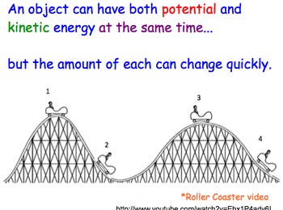

**LT2- I can calculate/find the speed of an object when given distance and time.**

1. Be able to draw the triangle of Physics. (Show all work using the 3 step method for all 3 problems.)

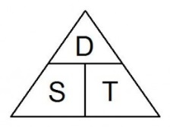

1. A jet airliner flies 4100 km from New York City to San Francisco in 4.25 Hrs. What is its average speed?
2. How long would it take a bus traveling at 50km/h to travel 125 km?
3. If you travel at an average speed of 70 mi/h for 7 hours how far did you travel?

**LT-3 I can interpret a graph that shows motions of an object and tell if it is at rest, accelerating, or maintaining speed.**

Be able to label the type of motion happening for each of the examples on the picture to the right. Letters A-E.

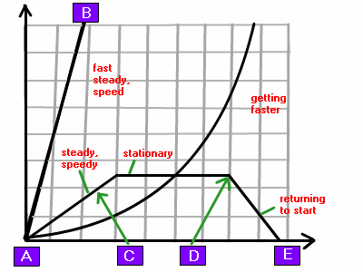

**LT-4 I can measure changes in motion of an object and write them in a data Table**

Create a data table for the following observations:

A cat moved at a constant speed of 1 meter per second for 10 seconds, then sat down still for 5 seconds.

|  |  |
| --- | --- |
|  |  |
|  |  |
|  |  |
|  |  |
|  |  |
|  |  |
|  |  |
|  |  |
|  |  |
|  |  |
|  |  |
|  |  |
|  |  |
|  |  |
|  |  |
|  |  |

**LT-5 I can grapy an objects’ changes in Motion.**

Draw a time-distance(position) graph using the following data:



|  |  |
| --- | --- |
| Time (s) | Distance (m) |
| 0 | 0 |
| 1 | 10 |
| 2 | 20 |
| 3 | 30 |
| 4 | 40 |
| 5 | 50 |

**LT-6 I can explain the changes in motion of an object using a graph**



**LT-7 I can describe changes in position, direction, and speed of an object when acted upon by an unbalanced force.**

For each of the box diagrams below, determine the net force acting on the object. Follow the format learned in May the Force Be With You worksheet. Then, write whether or not there will be a change in motion. If yes, write the direction the object will move (right or left)



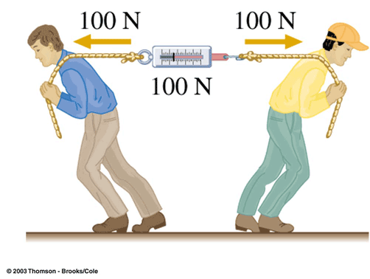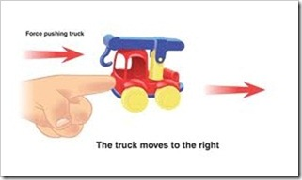Label each picture below as a balance force or an unbalance force and explain why its balanced or unbalanced.

______________________________ _____________________________

Why? _________________________ Why? ________________________

Draw an example /Give example of each of these types of forces:

|  |  |  |
| --- | --- | --- |
| Contact |  |  |
| Friction |  |  |
| Gravitational |  |  |
| Magnetic |  |  |
| Electrical |  |  |

**Force and Motion: Academic Vocabulary**

***Don’t forget to******Make and study flashcards for these vocabulary terms. Page numbers are in parentheses.***

Kinetic Energy (p. 207)  
Potential Energy (p. 207)

Force (188)

Motion (166)

Reference Point (p.164)

Types of Forces: (p.188-191 )

Contact

Friction

Gravitational

Magnetic

Electrical

Net Force (p.192)

Balanced Force (p.192)

Unbalanced Force (p.192)

Position (p.164)

Distance (p.165)

Displacement (p.165)

Speed (p.166)

Average Speed (p.167)

Constant Speed (p.166)

Velocity (p.168)

Acceleration (p.170)

X-axis (p.176)

Y-axis (p.176)

Distance-Time Graph (p.176)

Speed-Time Graph (p.180)

Air Resistance (p.191)