**States of Matter Review**

More

**\*\*Note –**

**Changing states is a**

**PHYSICAL change!**

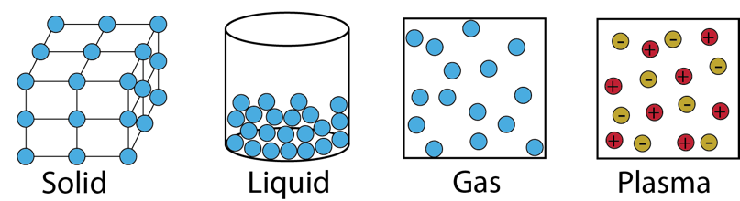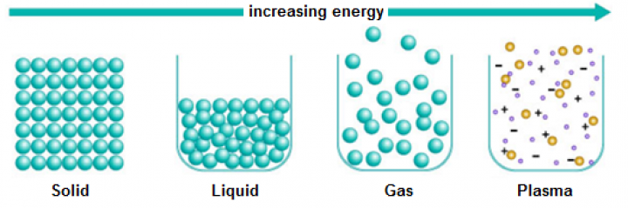

Energy

Decreasing

Increasing

Less

**Plasma** is a high **energy, electrically** charged mixture of **ions & electrons**.

**Solid**

* A **definite shape**
* A definite **volume**
* Particles are **close together**
* **Strong** attractive **forces** between particles
* Particles **vibrate in all directions**

Examples: **Ice, Rocks, Sulfur, Carbon**

**Liquid**

* No **definite shape- takes shape of container**
* Definite **volume**
* Particles are **close together**
* Weaker attractive **forces** between particles than in **solids**
* Particles free to move past each other

Examples: **Water, Juice, Bromine(Br)**

**Gas**

* No **definite shape**
* No **definite volume**
* Particles are very **far apart**
* Very weak **attractive forces** between particles
* Particles move **freely**

Examples: **Oxygen, Hydrogen, Water Vapor, Nitrogen dioxide**