STUNT RANCH

SCIENCE DAY!

Attention all sixth graders and parents!
Sixth Graders will be traveling to Stunt Ranch for a day of science fun and learning in an outdoor setting!!
When: November 15, 2013
Time Leaving WRMS: 8:30 a.m.
Time Returning to WRMS: 2:25 p.m.
Cost: $25.00 due by November 1, 2013
Please contact your child’s counselor should you need financial assistance.
(Send cash or check made out to WRMS and give it to your science teacher)
Waiver of Liability: Must be signed and returned with payment- see attached

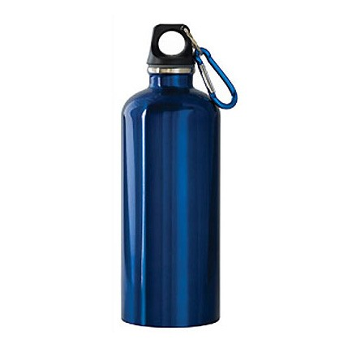What To Bring:
- A Sack Lunch
- Snack to have after returning to WRMS as kids will be hungry after the long day
- Dress for outdoor activities
- Wear sturdy footwear (Athletic shoes or hiking boots. No sandals or flip-flops.)
- Baseball or other brimmed hat
- Sun Block/Sun Screen
- Water bottle – may refill on site
- Towel- you may get wet
- Pants (No skirts or dresses!)
- Natural fibers only (No Rayon or Polyester. This is a safety policy, there is fire here.)

Waiver:
A waiver must be completed for EVERYONE coming to Stunt Ranch. Minors without waivers will not be allowed to participate. Please return completed waiver with payment by November 1, 2013.

